"Cooking is all about people. Food is maybe the only universal thing that really has the power to bring everyone together. No matter what culture, everywhere around the world, people eat together." ~ Guy Fieri
f |  | - Food Studies Grade 8 Mrs. Luthin  - 2021/2022
website: mrsluthin.weebly.com *** Voicemail: 250-870-5000 ext. 7866 |  | Email: chantal.luthin@sd23.bc.ca

Food Studies 8 Course Description
Food Studies 8 is part of the Applied Design, Skills, and Technologies provincial curriculum under the heading of Home Economics. This course builds on students’ natural curiosity, inventiveness, and desire to create and work in practical ways.
Foods 8 is a 10-week course (1/4 of the year) but the school has 3 official reporting periods. The student will regularly self-assess their learning progress. Students will also be given the opportunity to provide feedback to the teacher regarding their group's progress.
Curriculum Content:
- cross-contamination, including prevention and management
- food preparation practices
- effects of removing or substituting ingredients
- social factors that affect food choices
- variety of eating practices
- local food systems
- First Peoples food use and how that has changed over time
Cooking Labs
With the changes brought about by the COVID-19 pandemic, things will look a bit different in the foods classroom. As per the School District #23 communicable disease plan, we will still be cooking in groups but labs will be changed to allow adequate time for proper cleaning and sanitizing. Students will spend several weeks learning about proper safety and sanitation before working in the kitchens.

Complex tasks require the acquisition of additional skills.
Complex tasks may require multiple tools and technologies.
Design can be responsive to identified needs.

ADST Curriculum Big Ideas

Welcome
Welcome to a new year at Rutland Middle School. This is my 6th year teaching at RMS and I am so excited for another great year with the Voodoo family!

BC Curriculum
You can find the complete grade 8 curriculum here, https://curriculum.gov.bc.ca/.

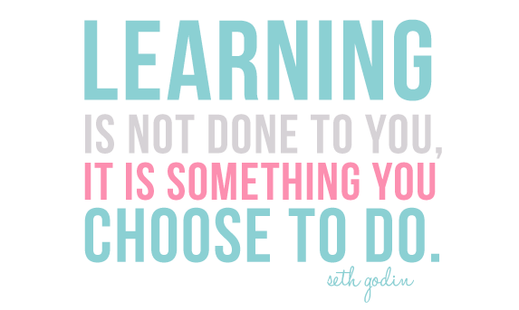
Expectations

General Class Information
- Attendance is essential for successful completion of this course.
- Do not bring backpacks or bags to class unless it is the last class of the day. Personal items brought to class will be stored on shelves on the side of the room.
- Electronic devices (cell phones, gaming devices, etc.) are not allowed in class, unless otherwise specified by the teacher. THIS IS A SAFETY & SANITATION ISSUE.
- Students with allergies and/or dietary restrictions must return a completed course objective acknowledgment form (handed out with the course welcome letter) for accommodations to be made.

Missed Class(es)?
- Any missed work (including cooking labs) can be completed at home by the student.
- Missed cooking labs – if your absence is excused, you can make up the missed lab by preparing the recipe at home. Failure to complete missed labs may result in a lower final grade.
  - Send me 3 pictures of YOU cooking, eating and cleaning up the missed lab.

*** Weekly updates on class work will be posted on my website: mrsluthin.weebly.com
There may be times the website may not be updated on a regular basis, so it is always best to check with me if your child is going to be absent.

Evaluation
Student marks will be based on both practical (cooking labs) and written work.
- Proficient –Skills and information covered in class have been practiced many times before. Student feels confident with the skills or information and can explain it. Student can work independently in the kitchen and often provide help to others in their learning and practicing of skills.
- Developing – Skills and information not new, student has tried it before but maybe not in the same way. Student can work more independently in the kitchen; requires some reminding or support from peers and/or the teacher.
- Approaching – Student is a beginner in the kitchen with the skills and information. Student requires a lot of help from peers and/or the teacher.
Work Ethic
Rutland Middle School
715 Rutland Road
250-870-5109
Work habit mark (G, S, N) includes, but is not limited to, classroom behaviour, participation, assignment completion, preparedness, and punctuality.
The best way to contact me is via email at chantal.luthin@sd23.bc.ca

